# Payment Plan

Create a web page (HTML5 + CSS3) that looks like the screenshot below:

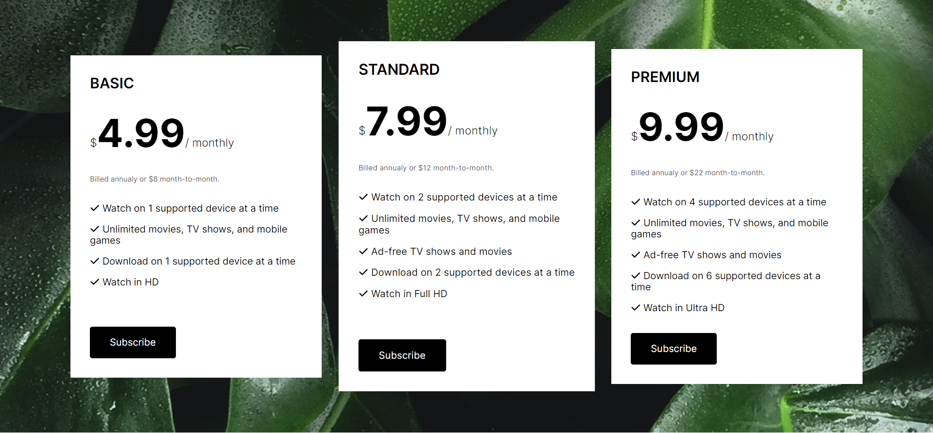

### Output

The output should be valid **HTML5** + **CSS3** + **images** that implement the above web page.

* Use the Google font **Inter**: <https://fonts.googleapis.com/css2?family=Inter:wght@100;200;300;400;500;600;700;800;900&amp;display=swap>.
* Font Awesome: <https://cdnjs.cloudflare.com/ajax/libs/font-awesome/6.3.0/css/all.min.css>.
* The site should open correctly in the **latest** version of **Chrome**.